RMS Business Analyst Guide
Recruitment Management System — roles, screens, permissions, business flows and how to use the system
Describes the version on the master and dev branches as of 3 October 2026 (roles plan, Phases 1-4, plus reports, the activity log and English-only text). Prepared from the code and the project documentation.
Purpose of this document: explain what RMS does today, who can use which screen, how each business process works, and what is still missing, so that new features can be analysed and proposed.

1. What RMS is
RMS is a small web application for running interviews. The HR or recruitment side keeps the lists of jobs and skills, registers candidates, and sees how interviewers scored each candidate.
Topic | Summary
Who uses it | Super Admins, HR staff, hiring managers and interviewers. Each person has one login and one role.
Where it runs | In a web browser, on desktop or phone. Nothing is installed on the user's computer.
What works today | Login, Users and Roles, Change password, Positions, Languages/skills, Jobs, Candidates with their profile and documents, assigning interviewers, interviewers' evaluations, Candidate Status (averages), interview scheduling, CSV reports, the activity log, the home page figures (dashboard) and the Selected / Rejected / On hold decision.
What is not built yet | E-mail or calendar notifications for interviews (to be decided later), Excel (.xlsx) and PDF reports.

Every menu entry opens a working screen.

2. Roles
RMS has four roles. A Super Admin sets each person's role on the Users and Roles screen.
Role | Purpose | What they can do today
Super Admin | Runs the system: users, roles and everything HR can do. | Everything: Users and Roles, Candidate Status, Candidates and their documents, Jobs, Positions, Languages, and permanently deleting a candidate's documents.
HR | Runs recruitment: reference lists, candidates, results. | Candidate Status, Candidates (add, edit, delete, profile, documents), assigning interviewers, decisions, Jobs, Positions, Languages. No user management.
Hiring Manager | Follows recruitment for their team. | Candidate Status and evaluations, the Candidates list and profiles, Jobs, and opening documents; read-only.
Interviewer | Interviews candidates and scores them on 10 criteria. | My Evaluations: scores the candidates assigned to them and sees those candidates' profiles and documents. Nothing else.
No role | Not intended; a data error. | Can log in, but sees only Home and Change password.

One role per person. There are no combined roles (for example a hiring manager who also interviews). Someone who needs two roles needs two logins today.

3. Who can open which screen
The menu shows each role only its own entries. Typing a page's address directly doesn't get around this: the server checks the role on every request, and any page not explicitly opened to a role is refused.
Menu entry / screen | Status | Super Admin | HR | Hiring Manager | Interviewer
Login page | Live | Yes | Yes | Yes | Yes
Home (welcome page) | Live | Yes | Yes | Yes | Yes
Recruitment › Candidate Status | Live | Yes | Yes | Read-only | Refused
Recruitment › Candidates | Live | Yes | Yes | List only | Refused
Candidate profile (click a name) | Live | Yes | Yes | Read-only | Assigned candidates only
Candidate's evaluations and decision history | Live | Yes | Yes | Read-only | Refused
Assign interviewers, record a decision | Live | Yes | Yes | Refused | Refused
Interviews › My Evaluations, evaluation form | Live | Refused | Refused | Refused | Assigned candidates only
Documents: upload, replace, delete | Live | Yes | Yes | Refused | Refused
Documents: open (download) | Live | Yes | Yes | Yes | Assigned candidates only
Permanently delete documents | Live | Yes | Refused | Refused | Refused
Recruitment › Jobs | Live | Yes | Yes | Read-only | Refused
Master data › Positions | Live | Yes | Yes | Refused | Refused
Master data › Languages | Live | Yes | Yes | Refused | Refused
Administration › Users and Roles | Live | Yes | Refused | Refused | Refused
Account › Change password | Live | Yes | Yes | Yes | Yes
Recruitment › Interview Schedule | Live | Yes | Yes | Read-only | Refused
Schedule, change or cancel an interview | Live | Yes | Yes | Refused | Refused
Interviews › My Schedule | Live | Refused | Refused | Refused | Own interviews only
Home page figures (dashboard) | Live | All figures | All figures | All figures | Own evaluations and interviews only
Reports (CSV downloads: candidates, candidate status, interview schedule) | Live | Yes | Yes | Yes | Refused
Administration › Activity Log, and its CSV download | Live | Yes | Refused | Refused | Refused
Log out (top bar) | Live | Yes | Yes | Yes | Yes

"Refused" means the user sees an "access denied" error page (HTTP 403) and the attempt is written to the server log. Anyone not logged in is sent to the login page.
The default is "nobody": any new screen a developer adds is refused to every role until a rule is written that opens it to the right roles.

4. How to change permissions
I want to… | How it's done | Who | New release needed?
Add a new user | Users and Roles › Add user: username, names, optional e-mail, phone and designation, role, and a temporary password. RMS gives the user an ID (U1, U2…). The user must choose their own password at first sign-in. | Super Admin | No
Change someone's role | Users and Roles › Edit › Role. It applies at once: the person is signed out at their next click and signs in with the new role. | Super Admin | No
Remove someone's access | Users and Roles › Deactivate. They can't sign in and are signed out at once. Nothing they did is removed, and Reactivate restores everything. | Super Admin | No
Reset a forgotten password | Users and Roles › Edit › Reset password, with a temporary password. The user must change it at their next page. | Super Admin | No
Change my own password | Account › Change password. | Everyone | No
Open a screen to another role | A developer adds an access rule and the menu entry for that role; the application is then rebuilt and redeployed. | Developer, then IT | Yes
Give one specific user extra rights | Not possible. Rights belong to the role, not to the person. | — | New feature
Create a new role | Not possible without development: new role value, access rules and menu. | Developer | New feature

Safety rules: a Super Admin can't deactivate, demote or reset themselves on this screen, and the last active Super Admin can't be deactivated or demoted.

5. Features in detail

Login and session
• Users sign in with username and password. A wrong password, an unknown user or a deactivated user all show "Invalid login!". If the database is unavailable, the page says sign-in isn't available right now.
• Lock: after 5 wrong passwords for one username from one computer within 15 minutes, that username is locked there for 15 minutes. The message stays "Invalid login!".
• After login everyone lands on Home, which greets the user and shows the tiles for their role. The top bar shows their initials, name and designation.
• Log out is in the top bar. After a period of inactivity the session expires (normally 30 minutes). A form left open too long shows "Your session expired. Please sign in again."
• If a Super Admin deactivates someone or changes their role while they are signed in, their next click shows "You were signed out because your account changed."
• There is no "forgot password" link and no self-registration: a Super Admin resets passwords.

Users and Roles (Super Admin)
• A list of every user, active or not, with ID, name, username, role, designation and status. "Must change password" marks users with a temporary password.
• Usernames: 3 to 100 letters, digits or . _ @ -; each username can be used once, also counting deactivated users. The ID and username can't be changed later.
• Passwords: at least 8 characters. They are stored scrambled (bcrypt), never as readable text.

Change password (everyone)
• Current password, then the new one twice. The new one must differ from the current one.
• After 5 wrong current passwords in 15 minutes the page refuses for 15 minutes.

Positions (master data)
• The list of job positions candidates apply for, for example "SOFTWARE ENGINEER".
• Super Admin and HR can add, rename and delete. Names are saved in capital letters and must be unique among active positions; a duplicate shows "Position NAME already exists."
• Delete is a soft delete: the position disappears from lists and dropdowns but stays in the database, so past candidates keep it. Adding the same name again brings the old one back.

Languages (master data)
• The languages or skills candidates are assessed on, for example "JAVA". Works exactly like Positions.

Candidates
• Super Admin and HR can add, list, edit and delete candidates. Hiring Managers see the list and the profiles. Each candidate has a first name, a last name, one position and one language, and optionally an e-mail, a phone number, a source (Referral, Job board, Website, Agency, Walk-in, Other), the date they applied, and a job.
• Job link: choosing an open job sets the candidate's position to the job's position automatically.
• RMS gives each new candidate an ID automatically: C1, C2, C3… The ID can't be changed and is never reused, even after a delete.
• Only active positions and languages can be chosen. If a candidate's position is deleted later, the candidate keeps it (shown as "NAME (deleted)" when editing).
• Delete is a soft delete: the candidate leaves the Candidates list and Candidate Status; their evaluations stay in the database.
• The list shows each candidate's status: Selected, Rejected, On hold or Pending.
• The list also shows each candidate's documents at a glance: "CV ✓ · 4/6" means a CV is there and 4 of the 6 document kinds (CV, SSC, HSC, BSc / Honours, Masters, PhD) are uploaded; "No CV" means the required CV is missing.

Candidate profile and documents
• Click a candidate's name to open their profile: details, job, and documents grouped by kind. Staff also see the assigned interviewers (Super Admin and HR assign and unassign them there) and the latest decision.
• Kinds: CV (required), SSC, HSC, BSc / Honours, Masters and PhD certificates (one each), and up to 5 professional certificates, each with a title (for example PMP) and an optional issuer and year.
• Files: PDF, JPG or PNG, at most 5 MB. RMS checks the file name, the type the browser reports and the file's content; anything else is refused with a message.
• Replace: uploading a CV or certificate again replaces the old one. A sixth professional certificate is refused until one is deleted.
• Delete (Super Admin, HR) hides a document after a confirmation. The file itself is kept until a Super Admin deletes the candidate's documents permanently.
• Permanently delete documents (Super Admin only): removes all the candidate's stored files, including replaced and deleted ones, after a confirmation and with a required reason. It can't be undone. RMS never deletes documents by itself.
• Documents open as downloads, for staff and for interviewers assigned to the candidate.

Jobs
• A job is an opening for a position, with a number of vacancies, an optional closing date and a status, Open or Closed, set by HR. Nothing closes a job automatically.
• Super Admin and HR can add, edit and delete jobs (a soft delete: candidates linked to it keep the link). Hiring Managers see the list.
• Only open jobs can be chosen for a candidate. A candidate whose job is later closed or deleted keeps it.

Interviewers and evaluations
• Assigning: on a candidate's profile, Super Admin and HR assign one or more interviewers. Only active users with the Interviewer role can be assigned.
• A deactivated interviewer keeps their assignments, flagged "interviewer inactive", so HR can see them and reassign. Reactivating restores everything.
• Unassigning keeps the interviewer's evaluation: it still counts, but they can't change it any more.
• My Evaluations (interviewers): the assigned candidates, with "To do" or "Submitted".
• Evaluation: each of the 10 criteria is scored from 1 to 10 (total at most 100), with an optional comment per criterion and an overall comment. The candidate's documents are listed beside the form. One evaluation per interviewer and candidate: saving again changes it.
• Locking: evaluations can be changed until the candidate is Selected or Rejected. On hold doesn't lock them.

Candidate Status (results)
• One row per candidate (deleted candidates are hidden): the number of evaluations, the average of each criterion over all evaluations, the total of the averages, and the decision.
• Click a name for each interviewer's scores and comments, the averages and the decision history.
• The table can be searched, sorted and paged.

Decision
• Super Admin and HR choose Selected, Rejected or On hold, with a required reason and a date (not in the future). RMS never decides by itself.
• A decision is allowed before any evaluation (the page warns). It can be changed later; every decision is kept in the history with who made it and when.
• Selected and Rejected lock the evaluations; On hold doesn't.

Interview schedule
• Super Admin and HR schedule an interview from Interview Schedule › Schedule interview: first choose the candidate, then the interviewer (only people assigned to that candidate whose account is active are offered), the date and time, and an optional location.
• Times are the server's local time, as typed. Two interviews for the same interviewer at the same start time are refused. Past times are accepted.
• An interview can be changed, marked Done or cancelled. Cancelling keeps it in the list, marked Cancelled, and a cancelled interview can't be changed. RMS never marks an interview Done by itself and sends no notification.
• Hiring Managers see the whole list read-only. Interviewers see only their own interviews, under My Schedule.

Reports
• Reports (menu, for Super Admin, HR and Hiring Manager) offers CSV downloads that open in Excel: Candidates (with status and the reason for the decision), Candidate Status (evaluation count, the average of each criterion, the total and the status) and Interview Schedule. A Super Admin also sees Activity Log.
• A download contains what the matching screen shows, nothing more. A cell that starts with = + - or @ is shown with a leading apostrophe so that Excel never runs it as a formula; phone numbers that start with + therefore show an apostrophe.
• Every download is recorded in the activity log. Excel (.xlsx) and PDF files are not offered.

Activity log (Super Admin)
• Activity Log (menu, Super Admin only) shows the newest 500 recorded actions with the time, the user, the action, the candidate or user it concerned and a short detail. It can be filtered by action and downloaded as CSV. Nobody can edit or delete an entry in RMS.
• Recorded: Marked (an interviewer saved an evaluation, with the total score only), Selected, Rejected and On hold (decisions; the reason stays in the decision history), interviewer assigned or unassigned, interview scheduled, changed or cancelled, candidate added, changed or deleted, user added, changed, deactivated, reactivated or given a new password, and report downloaded.
• Not recorded yet: sign-ins and sign-outs, document uploads and deletes, jobs and master data. Details never hold scores per criterion, comments, reasons, names or passwords.

English only
• RMS accepts English text only: letters, digits and common punctuation (no accented letters and no other scripts). It is checked for candidate and user names, designations, position and language names, decision reasons, evaluation comments and interview locations; anything else is refused with a message.
• Names already stored with other characters stay as they are, but such a candidate or user can be edited only after the name is changed to English.

Home page figures (dashboard)
• Super Admin, HR and Hiring Managers see: candidates by status (Selected, Rejected, On hold, Pending), evaluations still to do, upcoming interviews (with the next five), open jobs, candidates with no CV, and candidates with an inactive interviewer.
• Interviewers see their own evaluations still to do and upcoming interviews.
• "Evaluations still to do" counts an assigned, active interviewer who hasn't scored a candidate yet, not counting candidates already Selected or Rejected. "Candidates with an inactive interviewer" lists those who still need evaluations but have an assigned interviewer whose account is deactivated, so HR can reassign.

6. Business flows

End-to-end recruitment process
The process as built: every step is a working screen.
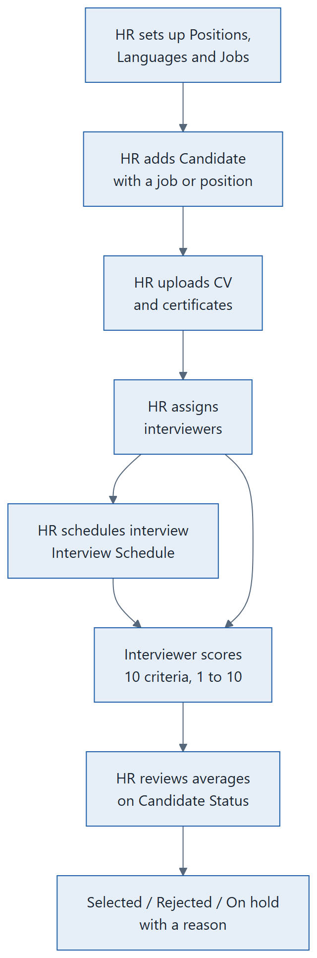
Recruitment process: every step is built

Login and role-based menu
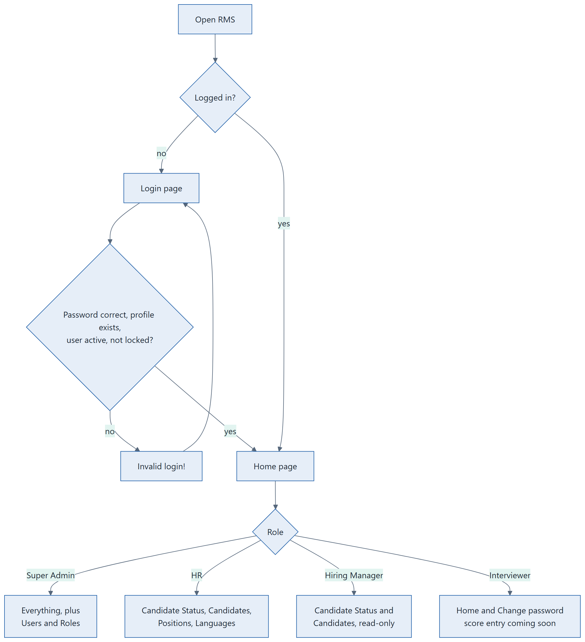
Login flow

Maintaining a list (Positions, Languages, Candidates)
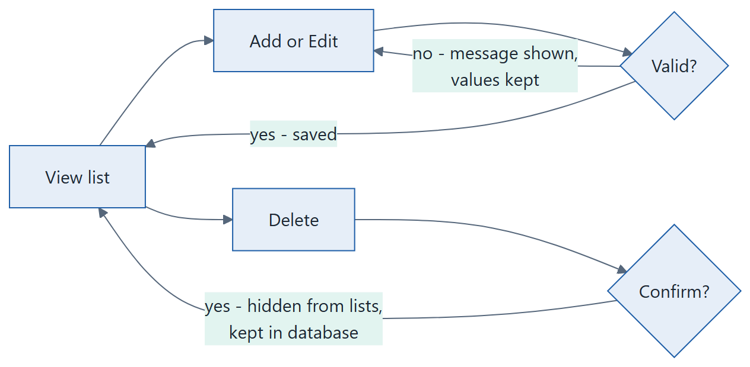
Add, edit and delete pattern shared by the list screens

7. How to use RMS

Super Admin: set up users
1. Sign in, open Users and Roles, then Add user.
2. Enter the username, names and role, and a temporary password twice. Save, then give the person the username and temporary password.
3. At their first sign-in they must choose their own password.
4. To change a role, click Edit. To remove access, click Deactivate and confirm.

Super Admin or HR: first-time setup
1. Open Positions and add each job you recruit for: Add position, type the name, Save.
2. Open Languages and add each language or skill you assess.

Super Admin or HR: register a candidate
1. Open Candidates, then Add candidate.
2. Enter the first and last name, choose a position and a language, then Save. RMS assigns the next ID (for example C3).
3. To correct details later, click Edit on the candidate's row. To remove a candidate, click Delete and confirm.

Super Admin or HR: add a job and documents
1. Open Jobs, then Add job: choose the position, enter the vacancies and (optionally) a closing date, keep the status Open, Save.
2. When registering or editing a candidate, choose the job; the position is set from it.
3. Open the candidate (click their name). Under Upload a document, choose the kind (for a professional certificate, also enter its title), choose the file and click Upload. Use Replace next to an existing document to upload a newer version.

Super Admin or HR: assign interviewers
1. Open the candidate (click their name on Candidates), go to Interviewers, choose an interviewer and click Assign.

Super Admin or HR: schedule an interview
1. Open Interview Schedule and click Schedule interview.
2. Choose the candidate and click Next.
3. Choose the interviewer, enter the date, time and (optionally) the location, and click Save. If no interviewer is offered, assign one on the candidate's profile first.
4. To change an interview use Edit (set Status to Done afterwards, if you like); to cancel it use Cancel and confirm.

Super Admin, HR or Hiring Manager: download a report
1. Open Reports and click the report you want (Candidates, Candidate Status or Interview Schedule).
2. Open the downloaded CSV file in Excel. Use only English when you enter data, so that names read correctly.

Super Admin: see who did what
1. Open Activity Log. Choose an action in the filter (for example Selected) and click Show.
2. Use Download CSV to keep a copy.

Super Admin, HR or Hiring Manager: review results and decide
1. Open Candidate Status. Use the search box, or click a column heading to sort (for example by Total Score).
2. Click a candidate's name to see each interviewer's scores and comments.
3. Super Admin and HR: under Decision, choose Selected, Rejected or On hold, give the reason and the date, and click Save decision.

Interviewer: evaluate a candidate
1. Sign in and open My Evaluations (menu or Home).
2. Click Evaluate next to a candidate. The documents are listed on the right.
3. Score all 10 criteria from 1 to 10, add comments if you like, and click Save evaluation. Use Edit to change it until the candidate is selected or rejected.

Everyone
• Change your password under Account › Change password.
• Use Log out in the top bar when you finish, especially on a shared computer.
• On a phone, open the menu with the button at the top left.

8. Business data
Business object | What it holds | Maintained in RMS?
User login | User ID (U1, U2…), username, password (scrambled), "must change password" flag | Yes (Users and Roles, Change password)
User profile | First and last name, e-mail, phone, designation, role, active flag | Yes (Users and Roles)
Position | Name (capitals), active flag | Yes
Language / skill | Name (capitals), active flag | Yes
Candidate | ID (C1, C2…), first and last name, position, language, e-mail, phone, source, applied date, job, status (S/R/empty), active flag | Yes, except the status
Job | Position, vacancies, closing date, status (Open/Closed), active flag | Yes
Candidate document | Kind, file name (shown only), file type and size, title/issuer/year (professional certificates), who uploaded it and when, deleted or permanently deleted (who, when, why). The file itself is stored outside the database | Yes
Evaluation (score sheet) | Interviewer, candidate, 10 scores (1–10), comments, when saved | Yes (interviewers)
Assignment | Candidate, interviewer, who assigned and when; unassigned (who, when) | Yes (Super Admin, HR)
Interview | Candidate, interviewer, start date and time (the server's time), location, status (Scheduled, Done, Cancelled), who created and changed it | Yes (Super Admin, HR)
Decision | Status (Selected, Rejected, On hold), reason, date, who decided, when; every decision kept | Yes (Super Admin, HR)
Activity log entry | Time, user, action (Marked, Selected, Rejected, On hold, interview, candidate, user and report actions), the candidate, user or report concerned, a short detail (for example the total score) | Written by RMS only; read by Super Admin

The 10 scoring criteria
Work Experience, Technical Knowledge, Leadership Skill, Decision Making, Problem Solving Skill, Stress Tolerance, Educational Background, Communication Skill, Attitude, Personality. Each is scored 1 to 10, so an evaluation's total is at most 100. Candidate Status shows the average of each criterion over all of a candidate's evaluations, and the total of those averages.

Candidate status
Shown as | Stored as
Selected | S
Rejected | R
On hold | H
Pending | anything else, including empty (new candidates start as Pending)

9. Business rules enforced by the system
• Position and language names are stored in capitals, trimmed, and must be unique among active entries.
• Deleting a position, language or candidate, or deactivating a user, hides or blocks it; nothing is physically removed, so history stays intact.
• Candidate IDs (C…) and user IDs (U…) are generated and never reused.
• A candidate needs a first name, a last name, an active position and an active language.
• A candidate's e-mail, phone, source and applied date are optional; the applied date can't be in the future. A job sets the position.
• Documents: PDF, JPG or PNG, at most 5 MB; one of each kind except professional certificates (up to 5, each with a title). Only a Super Admin can remove files, with a reason.
• Passwords must match exactly, including upper and lower case. An empty password never works. New and changed passwords are at least 8 characters and stored scrambled.
• A deactivated user can't sign in. A username that appears twice in the database can't log in. A user with a login but no profile can't log in.
• 5 wrong passwords in 15 minutes lock that username on that computer for 15 minutes.
• Interviewers see and score only the candidates assigned to them; scores must be 1 to 10; one evaluation per interviewer and candidate; no changes after Selected or Rejected.
• A decision needs a reason and a date that isn't in the future; it is made by a person, never by the system.
• An interview needs an interviewer who is assigned to the candidate and active, and a date and time; the same interviewer can't have two interviews at the same start time; only a Scheduled interview can be cancelled, and a cancelled one can't be changed.
• Text must be in English (letters, digits and common punctuation) in names, designations, position and language names, decision reasons, evaluation comments and interview locations.
• Marking, selecting, rejecting, holding, interview changes, candidate and user changes and report downloads are written to the activity log with the user and the time; the log can be read only by a Super Admin and can't be changed in RMS.
• Reports hold only what the matching screen shows; Interviewers can't download them, and only a Super Admin can download the activity log.
• Every change (save, delete, log out) must come from an RMS page; requests forged from other websites are refused.

10. What is missing or partial
Ref | Capability | State | Business impact
G34 | Names in non-Latin scripts (for example Bengali, Cyrillic) | Closed by decision | Only English is accepted, so such names are refused instead of being stored as unreadable codes. Names already stored that way stay until corrected.
— | Reports or export | Partial | CSV for Excel: candidates, candidate status, interview schedule and the activity log. No .xlsx or PDF, and no other reports yet.
— | Audit trail (who changed what, when) | Partial | The activity log records marking, decisions, interviews, assignments, candidate and user changes and report downloads. Sign-ins, document actions, jobs and master data are not recorded.

11. Decisions made (2 and 3 October 2026)
1. Scoring: each of the 10 criteria is scored 1–10 (total up to 100). Several interviewers can score one candidate; the result is the average of all evaluations, per criterion and in total. Interviewers can add comments.
2. Selection: Selected, Rejected or On hold is decided manually by a Super Admin or HR, never automatically.
3. Jobs: a Job is an opening built on a Position, with vacancies, a closing date and an open/closed status.
4. Deleted candidates are hidden on Candidate Status (built in Phase 3).
5. Inactive users can't sign in (built); their assignments stay, flagged "interviewer inactive".
6. Documents (built in Phase 2): only the CV is required; uploads are PDF, JPG or PNG up to 5 MB; HR's delete keeps the file; only a Super Admin removes files, with a reason; RMS never deletes documents automatically.
7. A job sets the candidate's position (built in Phase 2).
8. Evaluations and decisions (built in Phase 3): averages per criterion and in total; evaluations lock on Selected or Rejected, not On hold; decisions can change and are all kept; a deactivated interviewer's assignments stay, flagged.
10. Reports, activity log and English only (3 October 2026): reports are CSV files for Excel; the activity log records marking, selecting, rejecting and the other actions listed above and is read by Super Admin only; only English text is accepted; e-mail notifications will be decided later.
9. Interview schedule and dashboard (built in Phase 4): an interview is for an assigned, active interviewer; times are the server's local time; no notifications yet; the home page shows the figures listed above.

12. Open business questions
1. One role per user: is a second login acceptable for someone who both manages and interviews, or should a user hold several roles later?
2. Schedules: e-mail or calendar notifications will be decided later. Should past times be refused, and do all users work in the server's time zone?
3. Reports: which further reports are needed (counts per position, per status or per month; Excel or PDF files)?
5. Activity log: should sign-ins, document uploads and deletes, jobs and master data be recorded too? How long must entries be kept, and who archives them?
4. Documents of deleted candidates: a permanent delete is started from the candidate's profile, which a deleted candidate no longer has. Should that be possible for deleted candidates too, and is there a retention period after which documents must be removed?
Gap references (G…) and question numbers match the project's docs/gaps.md and docs/open-questions.md, so the development team can trace each item.

